Open event arrangements
Introduction
The first open event is an opportunity for the community to find out about Neighbourhood Planning and what it can and can’t do. It is also a chance to tell the local community what has been done to date and what still needs to take place. Finally, it is a potential recruitment opportunity to identify residents who may have something to offer to the process moving forward and are willing to contribute.
Ideally, the event should be promoted through village newsletters etc. several weeks in advance. Nearer the time (within one or two weeks) leaflets can be prepared to be delivered through people’s doors. Leaflets can also be left in local shops or pubs/cafes. The venue needs to be booked in advance and arrangements made for refreshments if these are being provided.
Large scale maps (size A0) need to be requested in advance from the District Council. These can include maps showing the designated area; the conservation area; heritage assets; flood zones; Limits to Development; Open Space, Sport and Recreation Sites; SHLAA maps; map of the built-up area etc. District Councils vary in what they will provide but should be asked to provide as wide a range as possible.
Arrangements for the day
Yourlocale
Access to the room is required 45 minutes prior to the start of the event. 9/10 trestle tables will be required to house the display boards. Yourlocale can bring all other equipment.
This will include display boards with relevant and local information on it; Guidance notes about what neighbourhood planning is; examples of other Neighbourhood Plans; post-it notes for people to make comments; flip-chart paper for the notes to be placed on; attendance sheets for people to record their presence, theme group interest forms for people to confirm their interest in becoming involved down the line and sticky dots for people to identify suitable sites for environmental protection/housing development (if wanted). We can also bring an A Frame to show people where the venue is.
One or two representatives from Yourlocale will be present on the day to answer any questions and to set up and take away the equipment. The post-it notes will be analysed and a report prepared showing all comments and summarising the event which can be used to inform the detail of the Neighbourhood Plan and to be part of the evidence base.
Members of the Parish Council/Advisory Committee
Name badges are helpful for members of the Committee and if refreshments are to be made available this should be organised by Members on the day. Ideally where possible:
- 2 people to be on reception to ensure people sign in
- 1 or 2 people telling people what to do on arrival and what it's all about ...
- People to serve tea and coffee
- 1 person on the open space exercise
- 1 person on the housing exercise
- 1 person on the display inviting involvement
- 1 person on map identifying land ownership
- Others floating .... if people wanted to stand by the display where their interest lies that is fine.
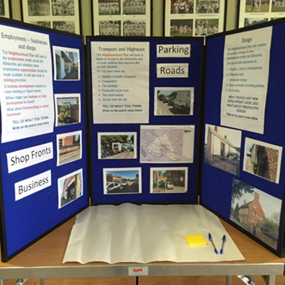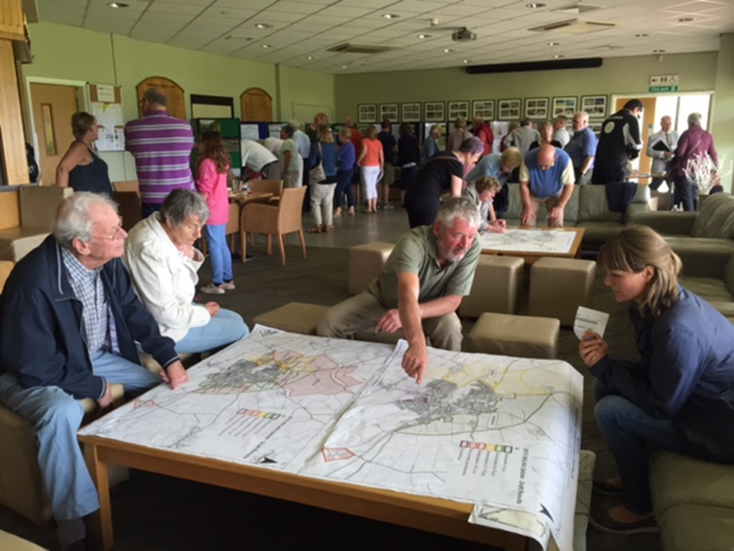
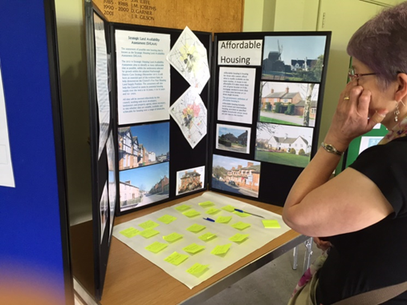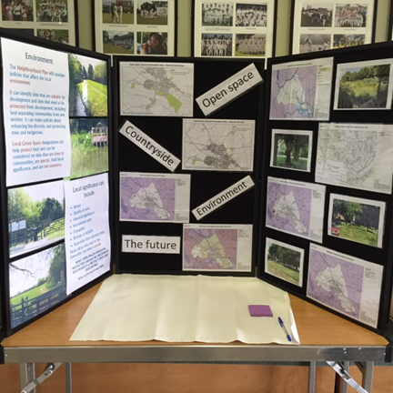
Gary Kirk
YourLocale

