**M6 Oxford Canal Viaduct - Nettle Hill joints replacement scheme - 1 March 2021 - 29 May 2021**

Upcoming maintenance works on the M6, near Coventry. This work will be carried out by contractor, Kier.

**What, why and the benefits?**

Routine maintenance work to the bridge that runs over the Oxford Canal Viaduct - Nettle Hill, between M6 junction 1 and junction 2. This will include replacing the bridge joints as they have reached the end of their serviceable life. At the same time, installing carriageway vehicle detection loops. These have been designed to detect traffic on the carriageway, set messages on the variable messaging signs, and to advise of road and traffic conditions including incidents ahead. The completed work will continue to provide a safer road, and reduce the need to return for future maintenance at this location any time soon.

**When will this work take place?**

From **1 March 2021** to **29 May 2021**. Work will be carried out overnight when traffic counts are lower between **9pm** and **5am**, **Monday** to **Friday**. To reduce disruption, the majority of work will be carried out under lane closures.

However, necessary full closure of the carriageway will be as follows:

**18 March** to **9 April**, full carriageway closure M6 junction 1 to junction 2 northbound;

**14 April** to **21 April**, full carriageway closure M6 junction 2 to junction 1 southbound;

**26 April** to **7 May**, full carriageway closure M6 junction 2 to junction 1 southbound.

No traffic management will be in place over the Easter Bank Holiday weekend (Friday 2 April to Monday 5 April).

Closures are subject to change due to weather or unforeseen circumstances. Any changes will prompt updates using the black and yellow signs.

**Diversion Routes**

During closures, a fully signposted diversion route (A426, A5 and M69) will be in place, see the map as follows:

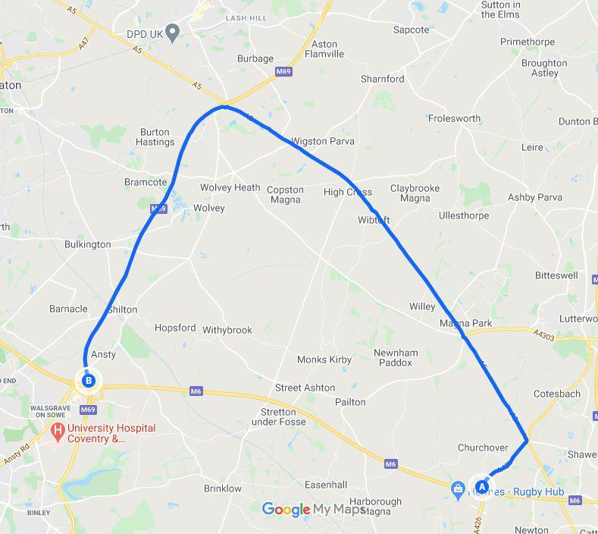

**Find out more**

If you have any questions, or if you would like to know more about this work, please call **0300 123 5000** or email info@highwaysengland.co.uk. You can also visit the website at highwaysengland.co.uk/roads/ or write to Highways England, National Traffic Operations Centre, 3 Ridgeway, Quinton Business Park, Birmingham, B32 1AF.

Please leave your feedback by completing our online survey. Just scan the QR code below.

