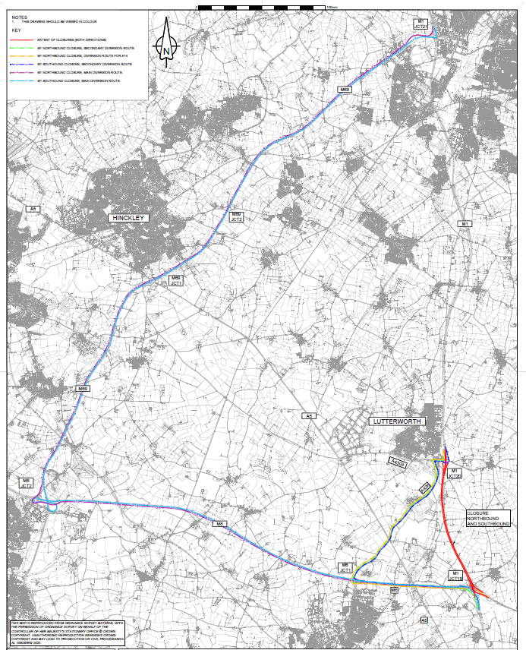
24-7 WEEKEND CLOSURE BETWEEN M1 J19 AND J20

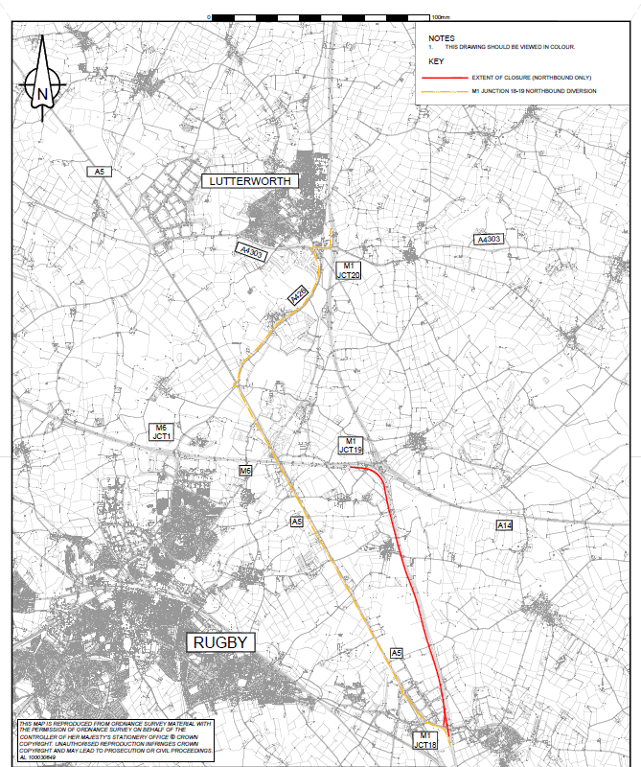
OVERNIGHT CLOSURE M1 J18 TO J19

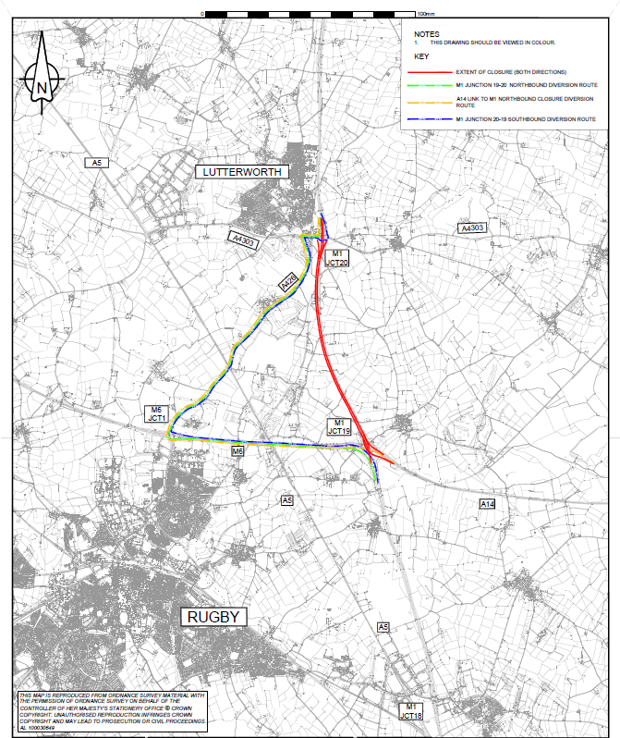
OVERNIGHT CLOSURE M1 J19 TO J20

